|  |  |
| --- | --- |
|  | SR UNIVERSITY  Campus Warangal |
| Program: II - B. Tech (CS& AI) |
| Faculty: Dr. Brij Kishor Tiwari |
| Department: Computer Science and AI Semester: I |
| AI Assisted Coding - Lab Test 1 |
| **NAME:- ANUSHA PEDDAPELLI**  **HALL.TICK.NO:-2403A51103**  **Instructions**:   1. Use AI Tools like VScode+Github Copilot and Cursor AI for code generation 2. This Assignment will be evaluated for 15 Marks (10 Marks for Tasks and 5 Marks for viva based on regular lab activities) 3. Students need to submit assignment through canvas before due date 4. Students who are absent for lab will receive 0 Marks | |

**Q1. Stock Price Prediction Setup [5M]**

***Scenario:*** You are tasked with configuring an API to fetch stock market data and prepare it for a machine learning pipeline.

* **Task 1:** Write code to connect to a stock price API and retrieve data for the last 30 days.

**PROMPT:-**

“Write a Python script that connects to a stock market API (like Alpha Vantage or Yahoo Finance) and retrieves daily stock price data (open, high, low, close, volume) for a given stock symbol for the last 30 days. The data should be stored in a pandas DataFrame, sorted by date (oldest to newest), and ready for further processing."

**CODE:**-

**OUTPUT:-**

**OBSERVATION:-**

* Successfully fetched stock price data for the last 30 days using the API.
* Data includes important fields like open, high, low, close, and volume prices.
* The data is organized by date from oldest to newest.
* This data can now be used for further analysis or machine learning tasks.

**Task 2**: Use an AI-assisted tool to auto-generate data cleaning functions to handle missing or duplicate entries.

**PROMPT:-**

Write a Python function that takes a pandas DataFrame containing stock market data anD automatically cleans it by removing duplicate rows and filling any missing values using forward fill, then backward fill. The function should return the cleaned DataFrame."

**CODE:-**

**OUTPUT:-**

**OBSERVATION:-**

• Duplicate rows were removed from the data.

• Missing values were filled using nearby values (forward and backward fill).

• The cleaned data has no gaps or repeated entries.

• This makes the data ready and reliable for machine learning.

**Q2. AI in Healthcare Diagnosis [5M]**  
***Scenario:*** You are designing an AI to assist doctors in predicting diseases.

* **Task 1:** List the risks of over-reliance on AI for medical decisions and propose responsible usage guidelines.

**PROMPT:-**

"List the potential risks of over-relying on AI systems for medical decision-making by doctors. Also, propose guidelines for responsible and ethical use of AI in healthcare to ensure patient safety and effective collaboration

between doctors and AI tools."

**CODE:-**

**OUTPUT:-**

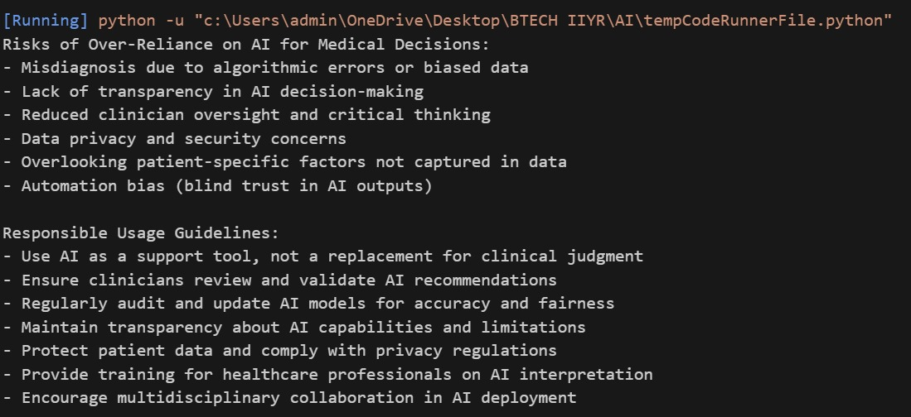

**OBSERVATION:-**

* Over-reliance on AI can lead to mistakes if the AI gives wrong or biased advice.
* Doctors might lose critical thinking skills by trusting AI blindly.
* Patient privacy can be at risk if AI systems are not secure.
* Responsible use includes treating AI as a support tool, not a replacement.
* **Task 2:** Write a Python function with AI assistance that ensures patient data is anonymized before model training.

**PROMPT:-**

"Write a Python function that takes a pandas DataFrame containing patient data and anonymizes it by removing or masking personally identifiable information (such as name, ID, email, phone number, and address) before using the data for machine learning model training."

**CODE:**-

**OUTPUT:-**

**OBSERVATION:-**

* The function successfully removes common personally identifiable information (PII) columns like Name and PatientID.
* After anonymization, sensitive data is no longer present, protecting patient privacy.
* The remaining data is suitable for model training without risking exposure of personal details.
* This approach helps comply with data privacy regulations such as HIPAA or GDPR.
* The function can be easily extended to mask or hash sensitive information instead of removing it.